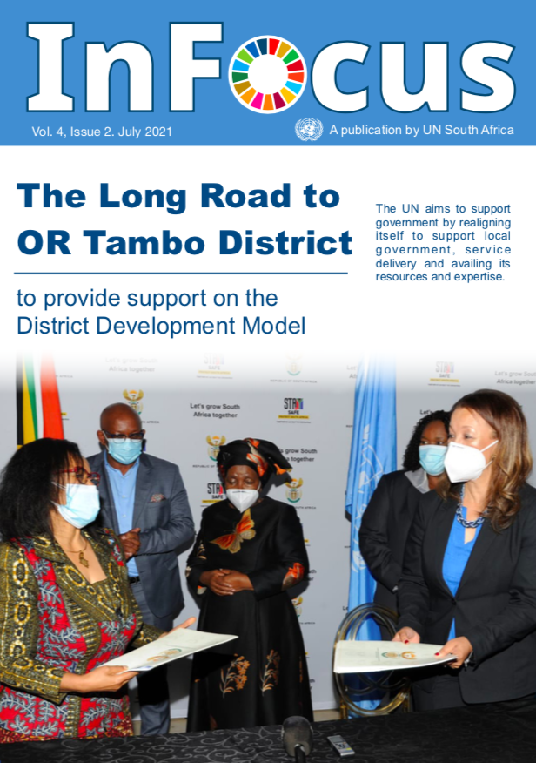

Message from Ms. Nardos Bekele-Thomas, UN Resident Coordinator in South Africa

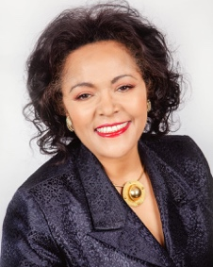
There is no doubt this last year has tested our resilience as individuals, families, organizations and as a global community. We have been challenged to look beyond our losses, to continue to push through adversities and exhaustion and to hold on to our pockets of joy. The pandemic continues to threaten the lives and livelihoods of many, while disrupting healthcare systems, hampering socioeconomic development. It has also disrupted the efforts of the global community to achieve the 2030 Sustainable Development Goals. READ MORE.....

The Long Road to OR Tambo District
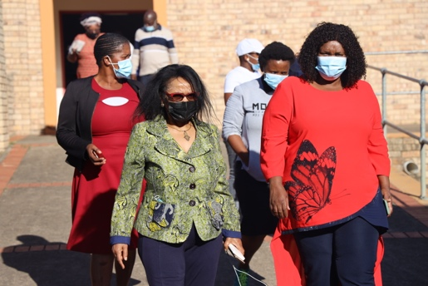 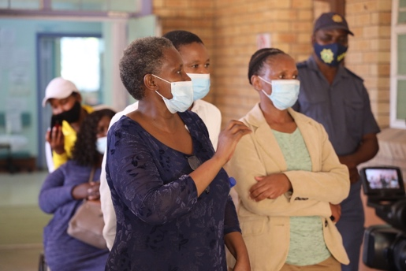 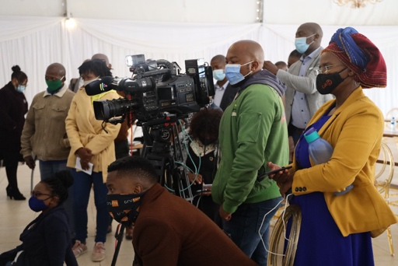
On a chilly early Tuesday morning with a light drizzle engulfing the small town of Mthatha in Eastern Cape Province, small bands of people started to trickle in at the sprawling country lodge for what many agreed was a ground-breaking signing ceremony for a partnership agreement between the Government and the United Nations in South Africa. As the hours ticked by towards the kick-off time for the event, organizers became increasingly anxious that the unforgiving weather would discourage many people from attending. READ MORE.....

‘We are with you’: The Sinawe Thuthuzela Care Centre providing hope for survivors of sexual violence
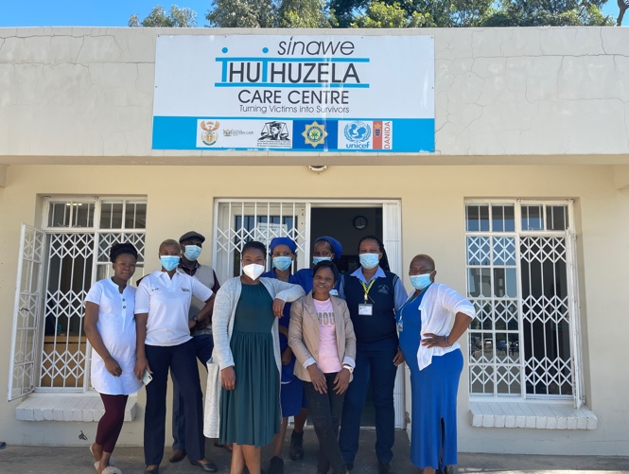 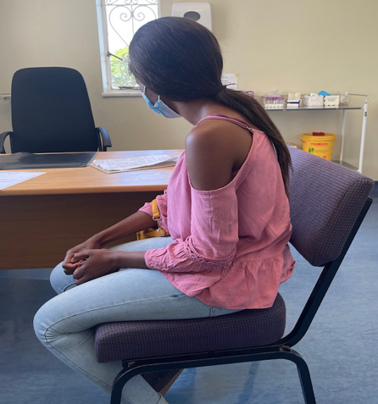
Lerato,* a 20-year-old first-year student at the local university, hunkers down on her chair a few metres from where I’m sitting, with her head fixed to the floor. She looks sad, tired and dejected, avoiding any eye contact, obviously ashamed of what we were going to talk about. READ MORE.....

Interview: Dr. Nomonde Ndyalvan, the Manager of Sinawe Thuthuzela Care Centre
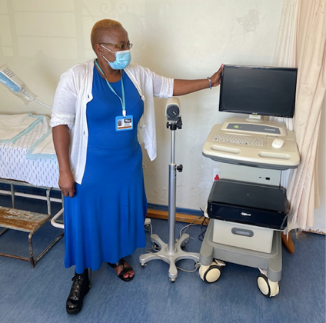 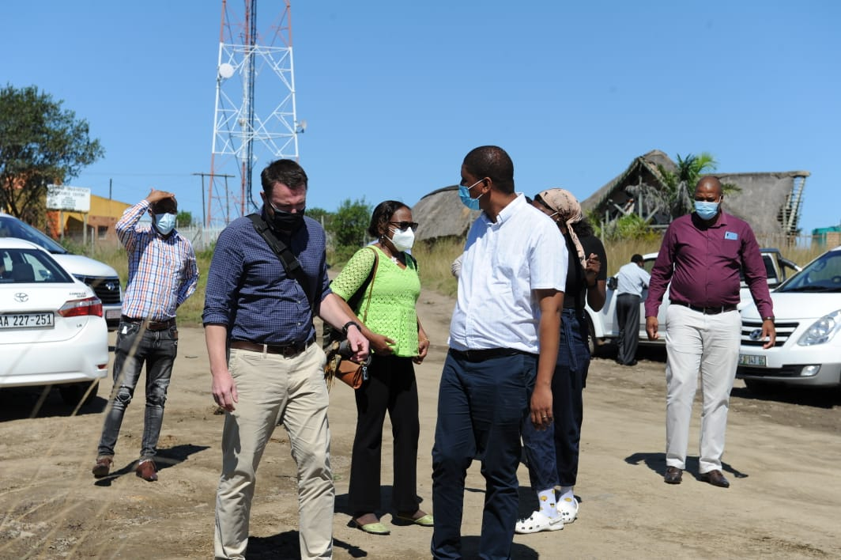
Dr. Nomonde Ndyalvan: I was an active member of Disabled People of South Africa and a gender activist in the community when I started volunteering at the centre in 2002. I used to work in the Casualty Unit after the centre was opened in 2001 by the then Minister of Health, Dr. Manto Tshabalala Msimang. We were only three full-time doctors in the Mthatha General Hospital’s casualty unit as there was a serious shortage of doctors. There were fights, feuds and vigilantism in the nearby Qumbu city in Mhlontlo Municipality. Women and children were coming in big numbers in the unit after being raped as rape was used as weapon of violence. READ MORE.....
The District Development Model launch kicks-off in Waterberg
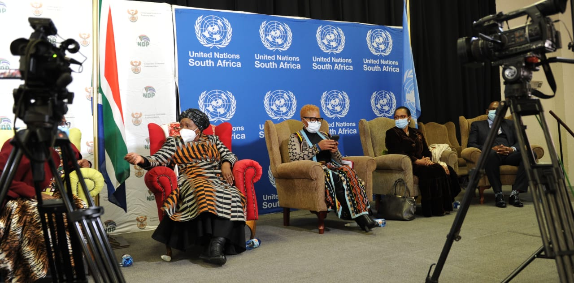 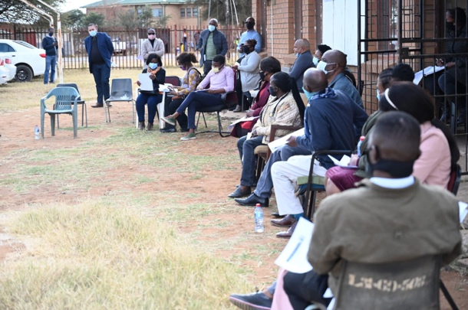
The initiative by the Government and the United Nations in South Africa to resuscitate district projects in the country’s three provinces picked up momentum in June when they gathered in Waterberg, Limpopo Province, to launch the partnership following a similar event in the Eastern Cape Province in April. READ MORE.....
UNHCR and the Government pledge to clear the asylum backlog by 2024
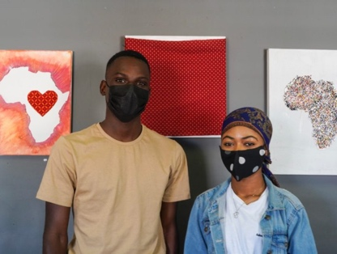 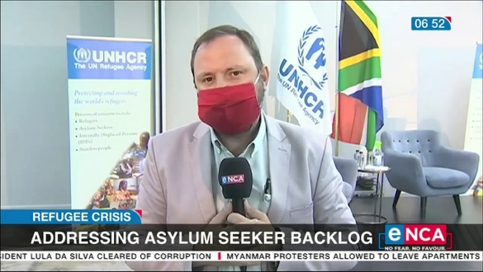
Under the Asylum Decisions Backlog Elimination Project, 153,391 cases will be processed over the next four years. Once their claims are processed, the people granted full refugee status will be free not only to access national services on a par with citizens, but also to become valuable contributors to South African society and the development of the country. READ MORE.....

“The blood we sacrificed was worth it”
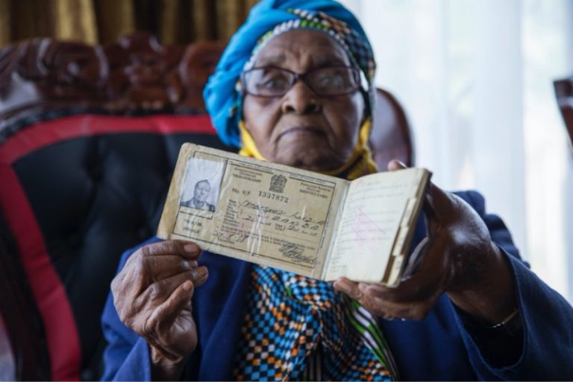 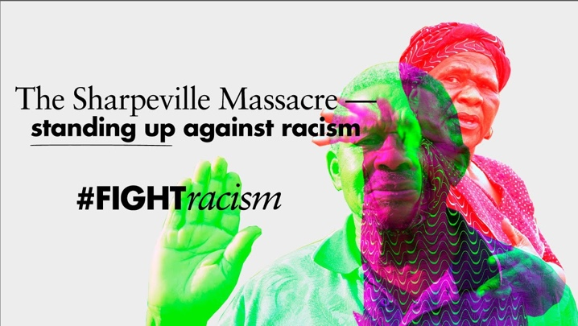
Selinah Mnguni was 23 years old and already three months pregnant when she was injured in the Sharpeville massacre on 21 March 1960. Attending a protest in peaceful defiance of the apartheid regime, Selinah and many other young people were demonstrating against pass laws designed to restrict and control the movement and employment of millions of Black South Africans. READ MORE.....
The Southern Africa Migration Management (SAMM) project inception
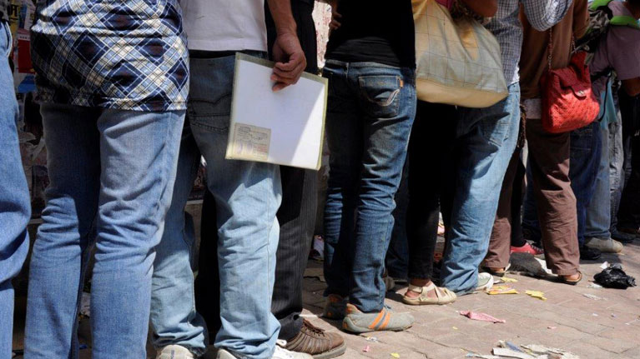
The Southern Africa Migration Management (SAMM) project is a model of a ONE-UN approach and collaborative effort between 4 UN development and humanitarian agencies: the ILO, the IOM, UNODC and UNHCR. The (SAMM) project forms part of the European Union Regional Indicative Programme (11th EDF RIP) for Eastern Africa, Southern Africa and the Indian Ocean (2014–2020) which focuses on South-South migration flows, identifying positive spill-over effects of international migration on regional integration and regional economic development. READ MORE.....

Cash Transfer to migrant domestic workers: ILO Covid-19 response compensating for income loss in Southern Africa
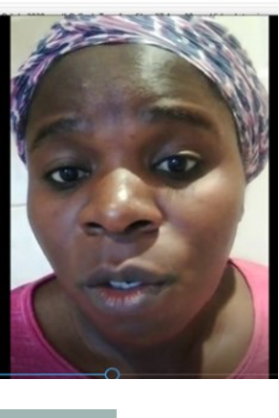 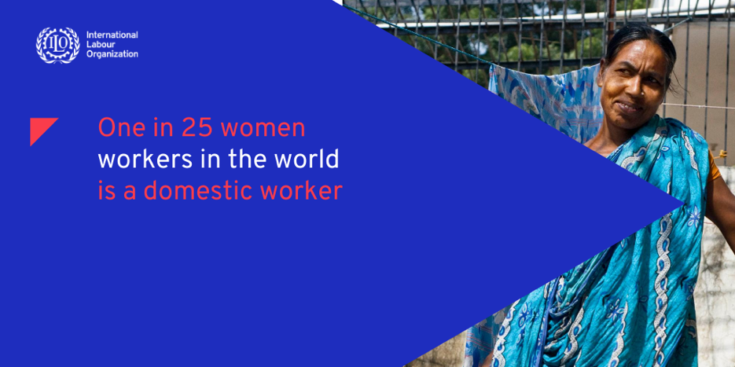
Love Kawula, a 44 year-old Malawian single mother working as a domestic worker for the past twenty years said that the corona virus pandemic has left a huge financial stress in households headed by migrant domestic workers, particularly those headed by females. READ MORE.....

Rural schools in Eastern Cape benefit from donation of sanitary dignity towels
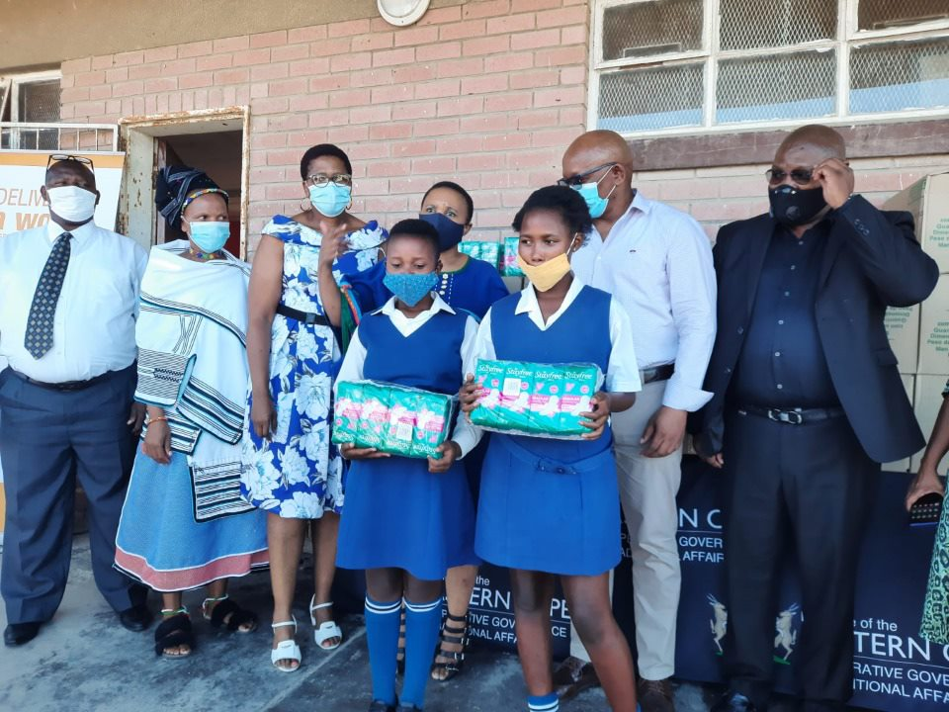 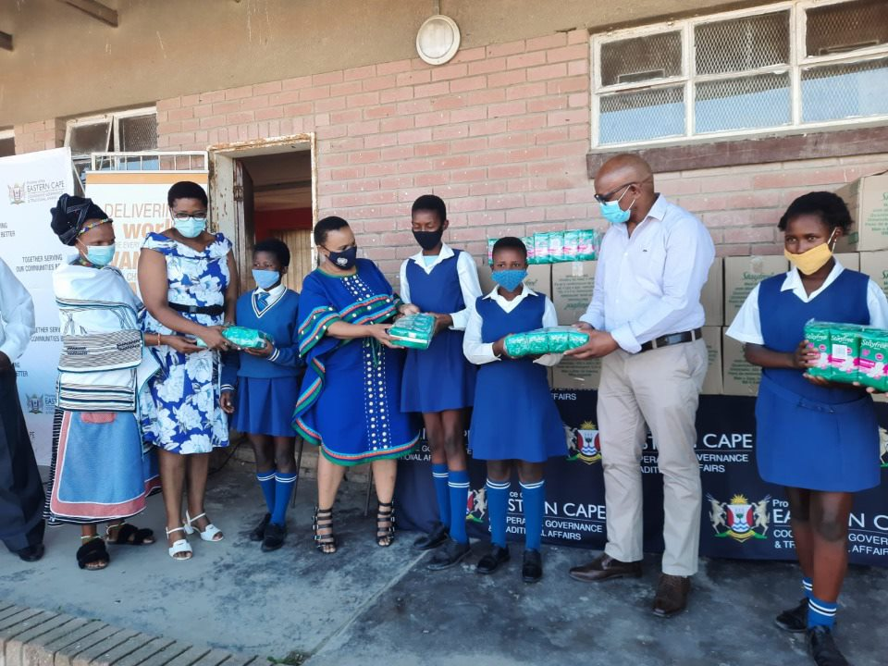
During the last quarter of 2020, the United Nations Population Fund (UNFPA) made a generous donation to the Eastern Cape Provincial House of Traditional Leaders as part of its response to the Covid-19 pandemic. The donation included sanitary dignity products, soaps, buckets and sanitizers. READ MORE.....
IOM food vouchers offer a ticket to survival for many migrants
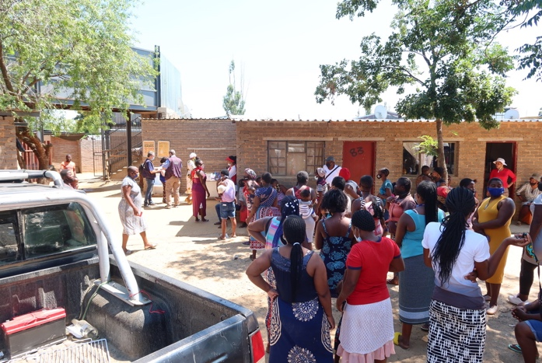 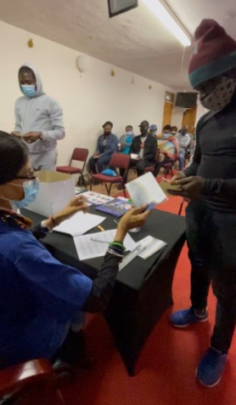
“I’ve lost my job. I gave birth. It’s been difficult as the child has disabilities too,” the words of despondent mother of two, Rebecca Bolona, 38, as she speaks to us in a small room upstairs of the Vitolina Centre, what is considered a busy “town” area in WierdaPark, Centurion, just outside South Africa’s capital, Pretoria. READ MORE.....
Thousands of youths take up the #TippyTapChallenge
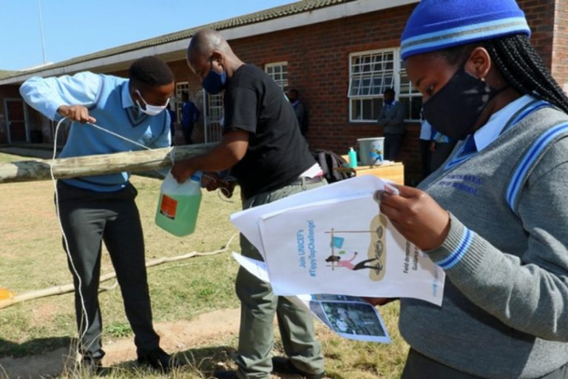 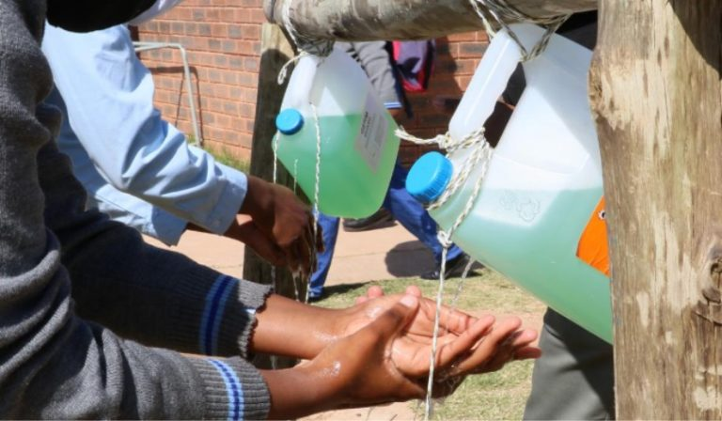
On a clear Eastern Cape day, the final year students of Limekhaya Secondary School are washing their hands in the thin stream of water that pours from a newly installed ‘tippy tap’ – a cheap and easy-to-build Do It Yourself (DIY) handwashing solution. READ MORE.....

New global AIDS strategy to end inequalities

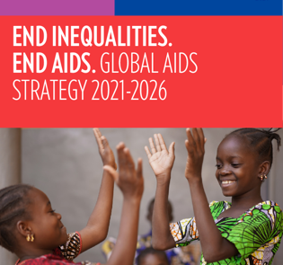
UNFPA leads the UN in South Africa at the launch of the National Youth Policy (NYP)
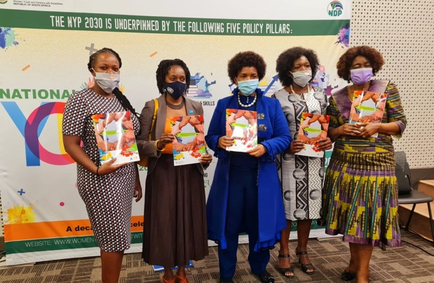
Boosting productivity and better working conditions in SA’s cloth manufacturing sector
In March this year, the Department of Women, Youth and Persons with Disabilities partnered with the United Nations Population Fund (UNFPA) and the National Youth Development Agency to launch the National Youth Policy 2030, under the theme: “A decade of accelerating positive youth development outcomes”. READ MORE.....
The South African National AIDS Council and South African civil society have strongly supported the new Global AIDS Strategy 2021-2026 that was formally adopted by the Programme Coordinating Board of the Joint UN Programme on HIV/AIDS (UNAIDS). READ MORE.....

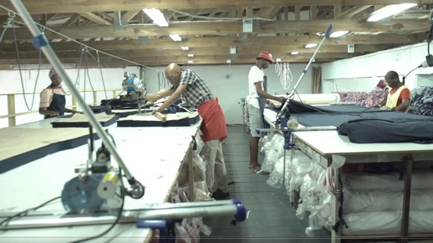 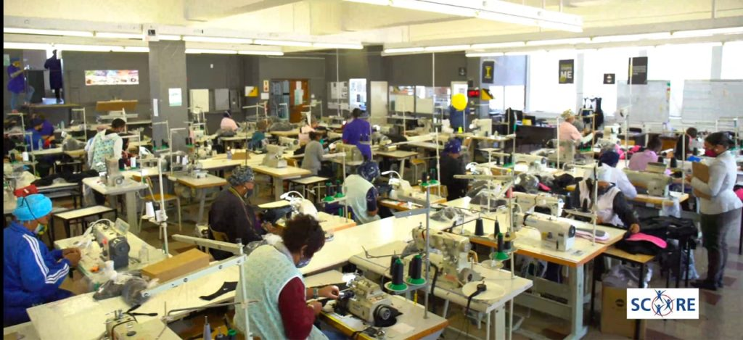
The 2018 Presidential Jobs Summit led to an agreement between the Government of South Africa and social partners to roll out inclusive and productive growth interventions in the manufacturing sector. The International Labour Organization (ILO)’s Sustaining Competitive and Responsible Enterprises Programme was subsequently piloted in collaboration with the National Bargaining Council for the Clothing and Manufacturing Industry. Other partners included the South African Clothing and Textile Workers Union, employers in the sector, Productivity SA and the European Union-funded Capacity Building Programme for Employment Promotion. READ MORE.....

Green shoots of hope growing in South Africa

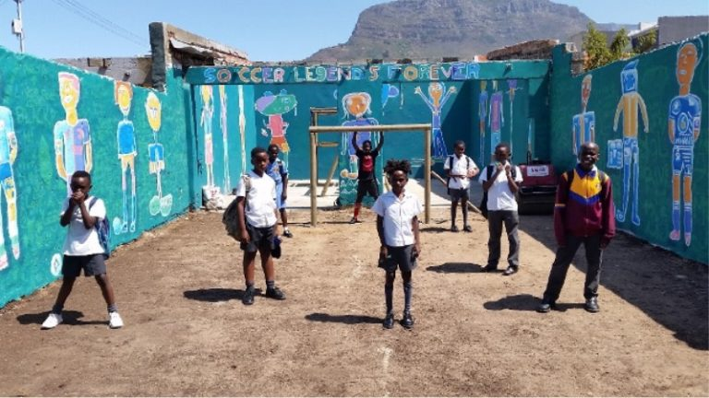
A little more than year ago, before South Africa declared a national state of disaster due to Covid-19, a group of inspiring people came together in Salt River, Cape Town at the annual International Public Art Festival to create something with a lasting benefit for the local community. READ MORE.....

Understanding grief during the pandemic

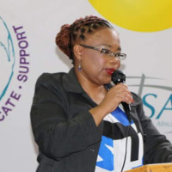 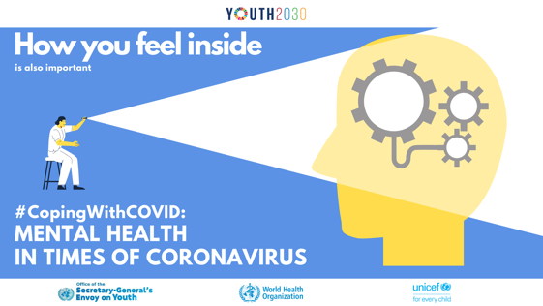
Helping Mozambique overcome crises
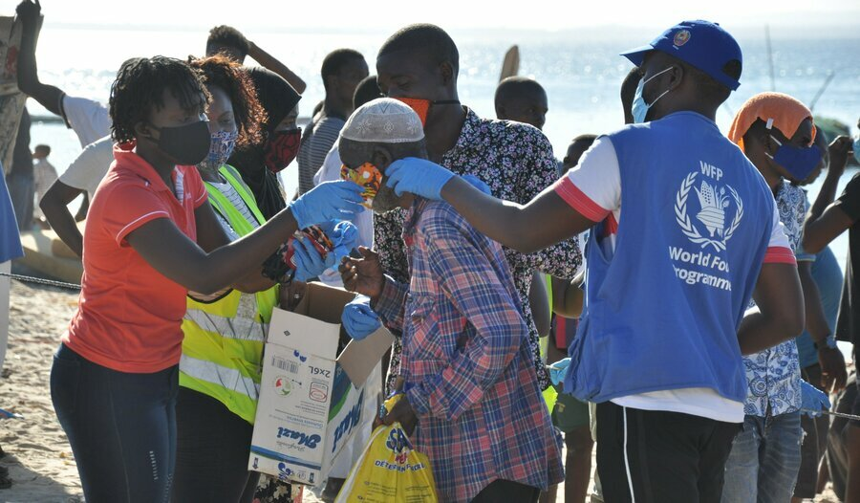 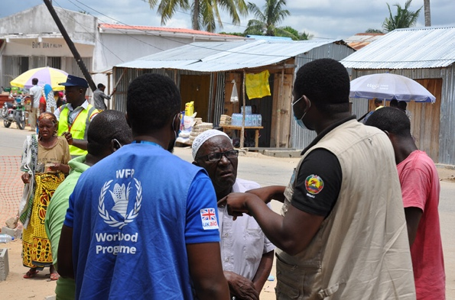
Mozambique has played such an inspirational role in the history of our continent, and is such a vibrant and beautiful country, that arriving here has always been a great joy. But on this visit, whilst so happy to be reunited with you, I share also in your pain and frustration at the humanitarian crisis from the conflict in Cabo Delgado. READ MORE.....
Grief is a natural and normal response to significant loss of any kind. Understanding the grieving experience, and how best to cope with it, can help in your recovery from such sadness or trauma. READ MORE.....

FAQs on the United Nations-Government’s Partnership on District Development Model (DDM)

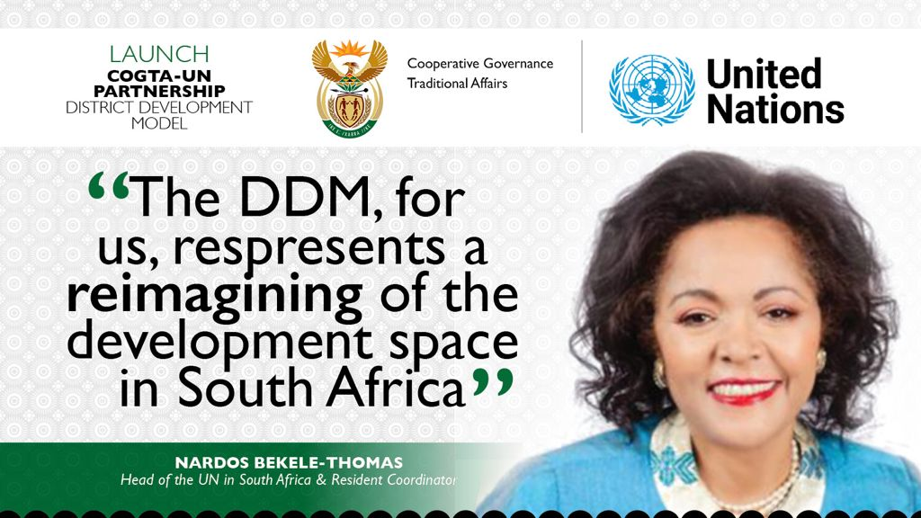
Working together as partners, the districts of OR Tambo (Eastern Cape), Waterberg (Limpopo) and eThekwini (KwaZulu-Natal) as well as Department of Cooperative Governance and Traditional Affairs (COGTA), the United Nations and other stakeholders have been able to identify bottlenecks to development that are affecting the efficient and effective delivery of services to local communities in the three districts. READ MORE......

MULTIMEDIA

- Ms. Nardos Bekele-Thomas, UN Resident Coordinator in South Africa, expands on the DDM partnership with government https://youtu.be/LPDwGUVDruc

- Ms.Anne Githuku-Shongwe, UN Women's Multi-Country Office Representative - UN in South Africa visits Thuthuzela Centre at Mokopane Hospital, Waterberg District in Limpopo. https://youtu.be/R526WFz-P_U

- Reflections from Ms. Beatrice Mutali, UNFPA Representative in South Africa - UN visits the Thusong Service Centre in Vaalwater, Waterberg District -Limpopo. https://youtu.be/39OSv_yVYQk

