**The International Organisation for Migration (IOM) South Africa**

**Terms of Reference**

|  |  |
| --- | --- |
| **Title:** | **An Assessment to understand the nature and impact of migration on SRH and HIV services utilisation among migrants and host populations in Ehlanzeni District:** |
| **Location of implementation:** | Ehlanzeni District: |
| **Duration** | 40 working days |

1. **Background and Programme Context**

The International Organization for Migration (IOM) is the United Nations (UN) agency for migration, a dynamic and growing inter-governmental organization with 175 member states worldwide. The IOM works to help promote safe, orderly and regular migration by working with stakeholders such as governments, civil society organisations (CSOs), migrants and other stakeholders. IOM addresses the migratory phenomenon from an integral and whole of society approach.

The 2030 Agenda for Sustainable Development calls upon all states to implement well-managed migration policies, and facilitate safe, orderly and regular migration. Similarly, the Global Compact for Safe, Orderly and Regular Migration (GCM)- a global framework on a common approach to international migration in all its dimensions – is a document that captures the commitments of heads of states to improve migration management. It recognises that migration is part of the human experience and will therefore require a multi-partner approach to manage migration for it to be beneficial to all. The GCM recognises that migration can contribute to prosperity, innovation and sustainable development and subsequently articulates 23 objectives for safe, orderly and regular migration.

The two key GCM objectives linked to the SRHR-HIV Knows No Border project work are objective one which focuses on the availability of accurate data and objective 15 which focuses on access to basic services for migrants. Objective 15 aims to ensure that all migrants, regardless of status, have safe access to basic services. This objective includes a number of recommendations to facilitate access to basic services by migrants. While the objective focuses especially on eligibility and access to health care and education, fundamental human rights also exist in relation to adequate housing, food, social security, and work, as set out in the International Covenant on Economic, Social and Cultural Rights. Under Objective 15, migrants should have safe access to basic services in all of these areas. In addition to recognising the rights of migrants to access basic services, it is critical to evaluate and monitor whether and how Objective 15 is implemented in national law, policy and practice.

Migration can contribute to human development when it occurs in a safe, orderly and regular manner. Similarly, globally, as migration is increasingly recognized as a determinant of health, the need to better understand the intersectional nature of migration and health is evident (Wickramage et al., 2018[1]). Central here is the growing acknowledgement that for the developmental benefits of population mobility to be realised, ‘healthy migration’ must be prioritised at global, regional, national, and local levels (ibid). Therefore, the link between migration, health, and development, requires evidence based data to inform policies that will promote development through migration. Ehlanzeni District in Mpumalanga Province borders both Mozambique and the Kingdom of Eswatini and subsequently greatly impacted by migration. The study has been commissioned by the IOM’s Migration and Health unit which is currently implementing the sexual and reproductive health and rights (SRHR) programme for southern Africa, titled the “SRHR and HIV Knows No Borders” (2020-2026) (KNB) project. The study findings are expected to inform strategic documents such as the distict’s integrated development plan (IDP), the development of a position paper on migration at the district level, strategies as well as programming in the district.

**1.1 Programme Context**

One of IOM’s areas of focus is Migration Management under which IOM implements migration and health interventions which address the health needs of individual migrants as well as the public health needs of transit and host communities. The KNB project is implemented in six countries in the southern Africa region namely: Kingdom of Eswatini, Lesotho, Malawi, Mozambique, South Africa, and Zambia by a consortium of two agencies IOM and Save the Children with generous funds from the Netherlands Government. It aims to contribute to improved SRH-HIV outcomes and quality of life among young vulnerable people (YVP) aged 10 to 29 years, including migrants and sex workers living in migration impacted communities in the six countries. The project is guided by three specific objectives as per the diagram below:

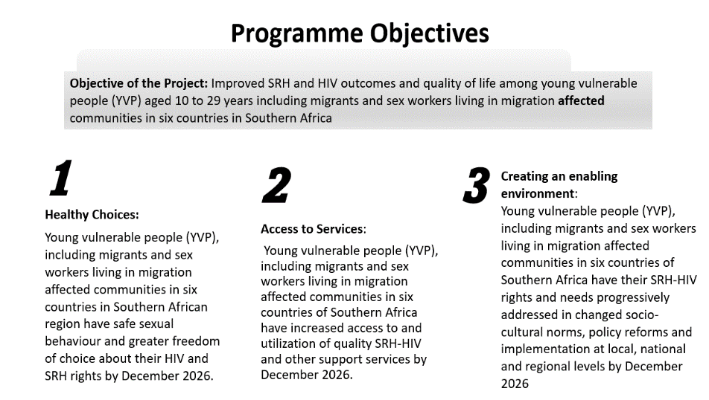

Figure 1 KNB Result Areas

The three pillars of the project enable IOM and Save the Children to tackle the root causes of poor SRHR and HIV outcomes among the target populations living in migration affected communities of Southern Africa.

Project strategies include generating demand for SRH and HIV services, encouraging service providers to make the services available, accessible, and relevant, and ensuring that services are supported by policy- and decision-makers at local, national and regional levels. Through the approaches utilised the project supports targeted populations in migration affected communities to exercise greater freedom of choice over their sexual lives. The project is aligned with the sustainable development goals 3, 5 and 8 and is implemented in collaboration with other UN agencies, ministries of health, National AIDS Councils, Civil Society Organisations, faith-based institutions and traditional structures.

In South Africa the project overview is captured in the following diagram.

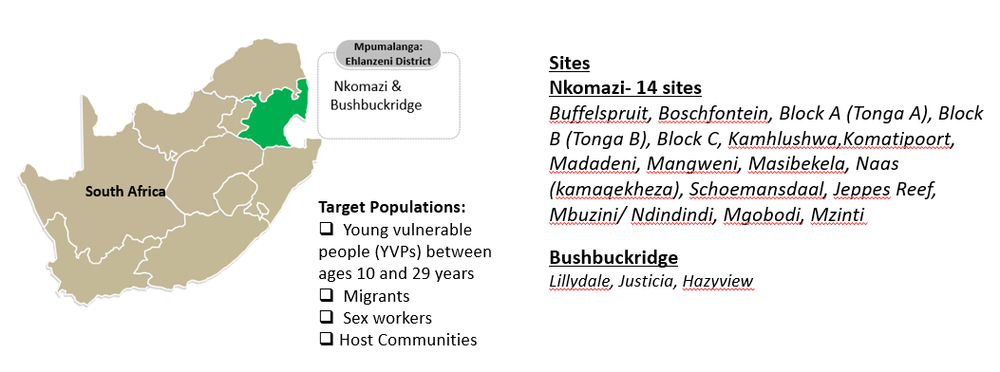

Figure 2 KNB Project Sites in South Africa

To conduct health promotion activities in Ehlanzeni District, IOM in partnership with Save the Children South Africa (SCSA) has 70 change agents who are capacitated to conduct health promotion in their communities. To create demand for services, the project uses a peer led approach using activities such as door to door health promotion, health talks at health facilities and community-based outreach campaigns. The project works with the Department of Health, Social Development, Department of Home Affairs (DHA), South Africa Police Services (SAPS) as well as other stakeholders. In Nkomazi the project is implemented by IOM’s implementing partner, Thembalethu Nkomazi.

1. **Overview Services required.**

The IOM in collaboration with the Ehlanzeni District Municipality (EDM) wishes to commission a research study to understand the nature and impact of migration in the district. The findings of the research report will be used to inform strategic documents which articulate the development plans of the district. In addition to this, it is expected that the research findings will be utilised to inform stakeholders programming including that of the KNB project. The district is home to one of the largest land borders, the Lebombo border post, which links South Africa and Mozambique. The district also shares six borders with the Kingdom of Eswatini. Apart from these formal border posts, there exist other informal border crossings which migrants move between the three countries in search of work, health services, family reunification etc. The movement of migrants into EDM is historical with migrants from neighbouring countries migrating for work in the farms and mines. With time the dynamic nature of migration is revealing patterns of migrants from as far as Asia and the Horn of Africa settling in the district.

**2.1 Objectives and questions the research study:**

Therefore the main objective of the study will be to document the nature of migration in Ehlanzeni District in order to identify how the trends impact access and utilisation of sexual and reproductive health services (SRH) amongst migrants and the host communities. The research will analyse mobility and migration patterns, trends, concerning the demographics and profiles of migrants moving along the district and its border lines as well as the implication of the trends on access and use of SRH services. It is expected the consultant will:

1. Undertake an analysis of the impact/effects of the emerging migration trends in the district.
2. Examine how the migration trends impact on access and utilisation of SRH services in the district and how challenges affecting utilisation of SRH services can be addressed.
3. Examine the developmental opportunities that migration presents to the district and the ways in which the district can maximise on the opportunities.

**2.2. Research questions will include:**

1. What is the impact of the emerging migration streams (rural-urban, urban-rural, urban-urban, rural-rural and cross-border) and demographic factors on SRHR-HIV services access and utilisation amongst different migrant and non-migrants?
2. What are structural drivers for cross-border and internal migration in the district and how do these impact SRHR services delivery (health systems level)?
3. What SRH and HIV health and social protection services exist in the district and how do access and requirements for access vary between migrants and non-migrant young people, sex workers that are in the district?
4. What is are the linkages between migration and health and development in the district?
5. What opportunities (social, economic, innovations) do the current migration patterns present and in what ways can the district and partners maximise on them?
6. What are the policy and strategic actions that can strengthen the district and partners response towards addressing the incidence of mixed migration flows, including appropriate protection frameworks to be instituted to reduce migrants’ and refugees’ vulnerability along the migration continuum?
7. **Methodology**

The method for this study will be a combination of a desk study and interviews with relevant stakeholders such as migrant and host communities, health and non-health duty bearers at district, and sub-district level. Secondary data that will be used will include research and data flow monitoring reports commissioned by IOM. The prospective service provider must outline their proposed research methodology and rationale for proposed approach when submitting their expression of interest. Overall, the methodology for the assessment will be agreed upon by the consultant in consultation with IOM.

1. **Expected Deliverables**

The selected consultant will be expected to deliver:

1. An inception report outlining the technical approach and methodology of the assessment (5 pager).
2. Literature review, research protocol, and tools
3. Undertake the ethical clearance process.
4. Conduct the study and submit a draft report.
5. Hold a validation meeting with the relevant stakeholders.
6. Submit a final report with power point presentation of the findings.
7. Design a dissemination brief summarising the findings.
8. Journal article manuscript in collaboration with select IOM staff members.

**5. Timeframe & COST**

The assignment will take approximately 40 working days, with a start date in October 2023. The service provider will receive an all-inclusive fee that will cover consultation fee, communication, travel, allowance and accommodation costs. The fees will be paid in accordance with deliverables in the following tranches:

i. 30% upon submission and acceptance of Inception Report.

ii. 50% upon submission and acceptance of the final draft Report.

iii. 20% upon validation and submission of final validated Report.

**6. Qualifications and Experience**

**Education**: Advanced university degree in Social Sciences, Migration studies, Public Health, epidemiology or Demography.

**Experience**:

A minimum of 7-10 years’ experience in migration management, international development, development policy, impact evaluations and research and analysis. Experience of research in Southern Africa region is desired. Experience working with the UN and international NGOs in the humanitarian and development context. Fluency in written and spoken English, additional language of Siswati and Portuguese will be an added advantage.

General skills: Demonstrated analytical skills and excellent communication and report writing skills; proficiency in Microsoft Office Suite applications (i.e. Word, Excel, PowerPoint) as well as quantitative and qualitative data analysis packages such as STATA/SPSS and Atlas.ti /Invivo

1. **Application process**

Interested organisations should submit their application proposals (clear and innovative concept proposal (5 to 8 pages maximum), a workplan and detailed budget of activities as mentioned in the TOR spread over 40 working days.

|  |
| --- |
| **7.1. Tender Process** |
| **Interested parties should submit applications in English to** [pretoriatenders@iom.int](mailto:pretoriatenders@iom.int) **using below references**  **Technical Proposal - IOM-UN/SRH/23/07-Technical**  **Financial Proposal – IOM-UN/SRH/23/07-Financial**    Proposals should be submitted by: 08 September 2023  For further information please contact [pretoriatenders@iom.int](mailto:pretoriatenders@iom.int) and quote the reference number or call +27 12 342 2789  All application files (email attachments) should not exceed 4MB.  IOM reserves the right to accept or reject any proposal and to annul the selection process and reject all Proposals at any time prior to contract award, without thereby incurring any liability to affected applicants.  **Please follow the method of application on the Terms of Reference.**  **INCOMPLETE APPLICATIONS WILL BE REJECTED** |

1. Wickramage, K., Vearey, J., Zwi, A.B., Robinson, C., Knipper, M., 2018. Migration and health: a global public health research priority. BMC Public Health 18, 987. https://doi.org/10.1186/s12889-018-5932-5